Each section of the NDP starts off with a paragraph called "Technical Requirements'. Some of you are struggling with this and it is actually a real-world problem that you will face in your future career. How do you determine the 'technical requirements' when none are listed? What I do is research specifications and other product information to see what is available and then take what I believe are the best of breed requirements and apply them to my desired list of technical requirements. For example, I may want a digital thermometer to record the temperature of equipment in my server room to make sure the temperature in the room is not out of tolerance for the equipment in the room. The temperature specifications for the equipment in the room are the driving factor and let's say the most restrictive item is a device that has to be maintained between 32F and 105F. Also, I have another item of equipment that has a temperature range of -10F to 160F. Other items of equipment have temperature specifications that fall within those ranges. I know that if the temperature falls outside of those ranges, then some of my equipment will probably fail or at least have a reduced life span.
Now I have to assume a few things. First, I should be able to set the temperature range that is critical for my equipment. Second, it should record the temperature so that I can actually see how far out of tolerance the temperature was and if any other equipment may have been affected. Third, device should set off an alarm/alert to let me know there is a problem.
Now that we have made these initial assumptions, we can take a look at some equipment specifications that are on the open market to see if there are any other bells and whistles that we might want to incorporate in our technical requirements. A quick Google search usually provides me with that information.
My first search result came up with a vendor called MicroDAQ [1] and they have a couple of temperature data loggers and recorders that might fit the bill.

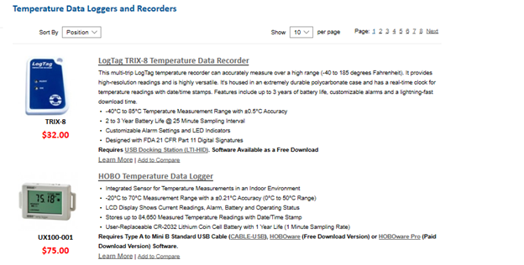

Therefore, I take a closer look at the specifications for each item to see if my technical requirements need to be modified and to see if I need to expand my search for more items of equipment [2].
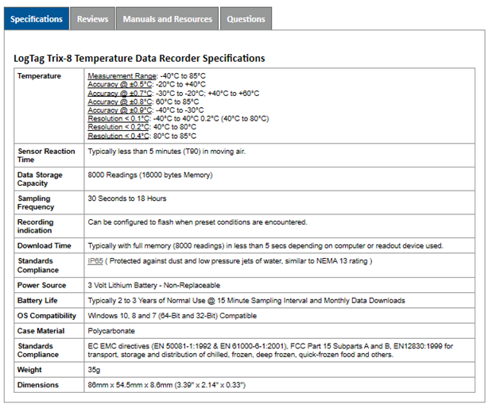
and the second set of specifications [3]:
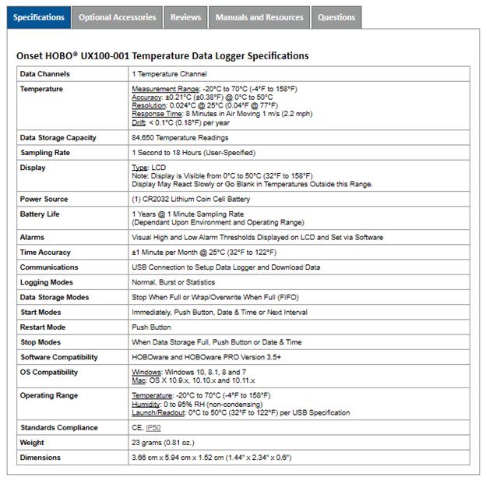
References
[1] | "Temperature Data Loggers and Recorders," MicroDAQ, [Online]. Available: https://www.microdaq.com/data-loggers/temperature.php?gclid=Cj0KCQjw4fHkBRDcARIsACV58_Ff-GOvANMzl6dvQa_2bPuswx4bppzIpIy-ud0IRwk0D1GiqjLEo2saAqPREALw_wcB. [Accessed 28 March 2019].
[2] | "LogTag TRIX-8 Temperature Data Recorder," MicroDAQ, 2019. [Online]. Available: https://www.microdaq.com/logtag-temperature-data-recorder.php. [Accessed 28 March 2019].
[3] | "HOBO Temperature Data Logger," 2019. [Online]. Available: https://www.microdaq.com/onset-hobo-ux100-temperature-data-logger.php. [Accessed 28 March 2019].

I know temperature ranges are important. Since the temperatures are listed in Centigrade, I convert my temperature requirements to Centigrade and for the minimum of -10F, I get -23C. For my high temperature of +160F, I get -20C to71C. Therefore, looking at the temperature ranges of each recorder, I see the HOBO only records between -20C and 70C and is not going to be good enough. The LogTag seems to meet my initial set of requirements. Therefore, I should do so more searches to see if there are any other temperature recorders that might compare more favorably.
In addition, I notice a few things that might be an important technical requirement to include in my technical requirements like: data storage capability, sample rate/frequency, accuracy, battery life, communications, logging modes OS compatibility, weight, dimensions, and alarm settings. This information is what I will use to determine my 'baseline' of technical requirements and see if I can find one or two more makes/models of equipment that compare to my new set of requirements. Finally, after verifying that I have one or more devices that meet my requirements, I will look at the cost and will most likely select the item that has the least cost. Factor that may affect the least cost selection is the perceived quality of the vendor, location of vendor...does it happen to be in China and does it matter?, or something else my client is interested in such as availability.
To make this all easily understandable, just create a business case analysis table using the 'new requirements in the first row and then start filling in the data for each make and model that might fit the bill. If it is a simple thing, I would only find one or two items. If it is very expensive, I might do an exhaustive research to verify that I have the best item available for my customer.

